MOUNT ZION COLLEGE OF ENGINEERING AND TECHNOLOGY

PUDUKKOTTAI.

Prof.Er.S.A.W.BUKARI Speaks on “Mentoring the Mentors” at Mount Zion on World Mental Health Day.

Mount Zion College of Engineering & Technology celebrated World Health Day at the college seminar hall in a grand manner. Principal Dr.P.Balamurugan presided over the function and delivered the Presidential address.

Mr.Srinivas SDP Cell Co-Ordinator welcomed the gathering. Placement Officer, Dr.O.T.John introduced the Chiefguest, Prof.Er.S.A.W.BUKARI, Former Deputy General Manager, BHEL, Trichy. Principal, Dr.P.Balamurugan, honoured the Chief Guest with a shawl. In his special address, Prof.Bukari congratulated the staff because they have A/C facility and Mobile Phones now. But the environment is not satisfying and it is not good.

Mobile phones spoil the society. Moral values are lost. Population is the greatest strength of our country. Indian population is 120 crores and 60% are youth. It is the greatest potential. Within 5 or 6 years youth should be trained, otherwise they would become a liability. New options are available. We have very good natural resources. Different ores are available in India like Titanium. But Japan does not have natural resources like India. Japan is the Second Economically developed country. It is because they have a question of survival.

We are in a period of Development. India is spending 1 Trillion dollars for Infrastructure alone. Oppurtunities are many and it is time to train the Students. T.V is the greatest disturbance to the students and they get wrong informations. They think of drugs, drinks and love . He raised the question, what do you think of youth? He said that youth is a period of strain & stress. Soon after studying XII Standard they want to run away from parents. How they relate, adult to adult? It is a transmission stage. From dependent stage they move to independent stage. He raised the question how the human potential can be made available? Potential can be blossomed after taking care of ummet needs wants and hurts. In the next session, Staff were divided into groups and they were asked to write about their strength. The interaction time was very lively. Every one appreciated the programme and it was an unforgettable one. Placement officer , Dr.O.T.John proposed the Vote of Thanks.

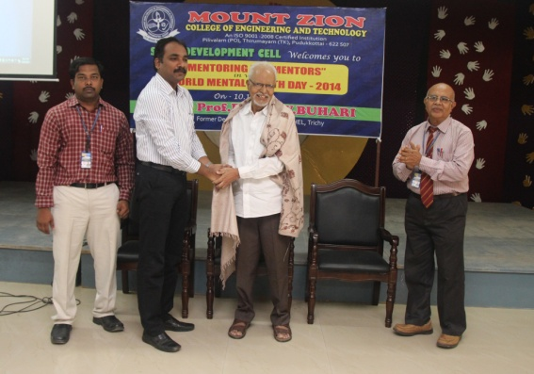

On the ‘World Mental Health Day’ Programme held at Mount Zion College of Engineering and Technology. Chief Guest, Prof.Er.S.A.W.BUKARI, Former Deputy General Manager, BHEL , Trichy is honoured by the Principal, Dr.P.Balamurugan along with him are S.D.P Cell Co-Ordinator Mr.Srinivas and Placement Officer, Dr.O.T.John.